Name : Kasak Patel
Roll No : 05
Sec-Batch : B-B1
ML Lab 1

Aim : To study and apply Data Preprocessing techniques on given dataset. Prepare a titanic dataset for training with machine learning algorithm by applying suitable data preprocessing techniques

OBJECTIVE
To perform data preprocessing on the Titanic dataset using Python by handling missing values, detecting and removing outliers, encoding categorical data, visualizing the data, selecting relevant features, standardizing numerical features, and splitting the dataset into training and testing sets for machine learning.
1.1 Theory:
Data preprocessing is an important step in machine learning in which raw dataset information is cleaned, organized, and converted into a suitable format for analysis and model development. Practical datasets may contain incomplete records, repeated observations, unnecessary columns, inconsistent data types, or unusually large and small values. If these problems are not handled properly, they can affect the accuracy and reliability of machine learning results.
1.2 Dataset Inspection:
Before applying preprocessing techniques, the dataset should be examined to understand its basic structure. Information such as the number of rows and columns, feature names, data types, statistical values, and sample records can be obtained using functions such as head(), tail(), shape, columns, info() and describe(). This initial analysis helps determine which columns need further preprocessing.
1.3 Handling Missing Values:
Missing data refers to entries where information is not available. Different methods can be used depending on the type and amount of missing information. In the Titanic dataset, missing values in the Age column are replaced using the median value, as the median is less affected by extreme observations. Missing values in the Embarked column are replaced with its most frequently occurring category. Since the Cabin column has a very high number of missing entries, it is removed rather than filling it with potentially unreliable values.
1.4 Checking Duplicate Records:
Duplicate records are identical rows that may appear more than once in a dataset. Such records can give excessive importance to the same observation and may affect the analysis. The duplicated().sum() function is used to identify complete duplicate rows. In this dataset, no duplicate records are found, so no duplicate removal is required.
1.5 Outlier Detection Using IQR:
An outlier is a value that is considerably different from the majority of observations.
Such values can influence statistical analysis and machine learning models. The Interquartile Range (IQR) technique is used to identify unusual values. IQR is calculated using: IQR = Q3 - Q1
where Q1 represents the first quartile and Q3 represents the third quartile. The lower and upper limits are calculated as: Lower Limit = Q1 - 1.5 × IQR
Upper Limit = Q3 + 1.5 × IQR
Values falling outside these limits are considered outliers. In this experiment, the IQR method is applied to the Age and Fare columns. Box plots are also used to compare the distributions before and after removing the outliers.
1.6 Encoding Categorical Data:
Machine learning algorithms generally work with numerical values rather than text categories. Therefore, categorical columns need to be converted into numerical representations. In this experiment, the Sex column is converted into 0 and 1, where male is represented by 0 and female by 1. Similarly, the Embarked column is converted into numerical values, with S represented by 0, C by 1, and Q by 2. This allows the categorical information to be processed by machine learning algorithms.

Materials and Software Used
- Python 3.x programming language
- Jupyter Notebook in Visual Studio Code
- Pandas and NumPy for data manipulation
- Matplotlib and Seaborn for visualization
- Titanic-Dataset.csv containing 891 passenger records and 12 original columns
- Git and GitHub for version control and source-code publication

Procedure
- Import Pandas, NumPy, Matplotlib and Seaborn.
- Load the Titanic CSV file into a Pandas DataFrame.
- Inspect the first and last records, shape, columns, data types and descriptive statistics.
- Count missing values and visualize their locations using a heatmap. 5. Fill missing Age values with the median and missing Embarked values with the mode.
6. Drop the Cabin column because it contains extensive missing data. 7. Check whether any complete duplicate rows are present.
- Visualize Age and Fare using box plots and remove outliers using IQR limits.
- Convert Sex and Embarked categories to numerical values.
- Review the final preprocessed dataset and publish the code on GitHub.
GitHub Repository Repository URL:
https://github.com/GauriRaut58/Gauri-
/blob/main/C_C4_52_GAURI_RAUT_ML_LAB_1.ipynb
The repository contains the Jupyter Notebook, Python script, dataset folder, README file, dependency list and Git configuration file. The source code can therefore be reviewed, executed and extended by faculty members or company recruiters.
PROGRAM CODE –

Load and Understand Dataset
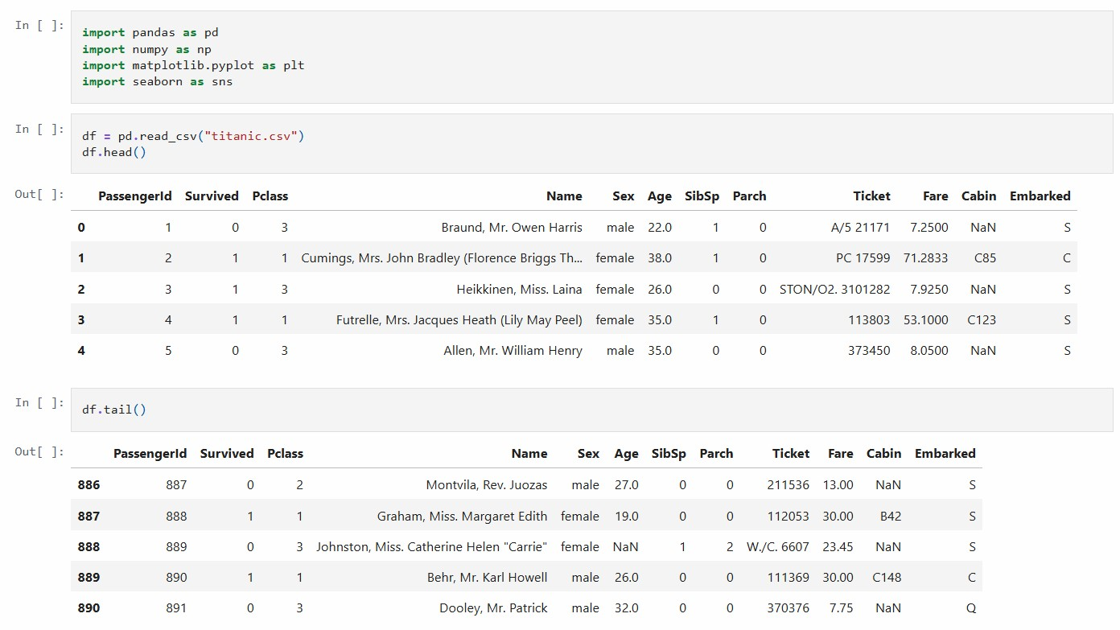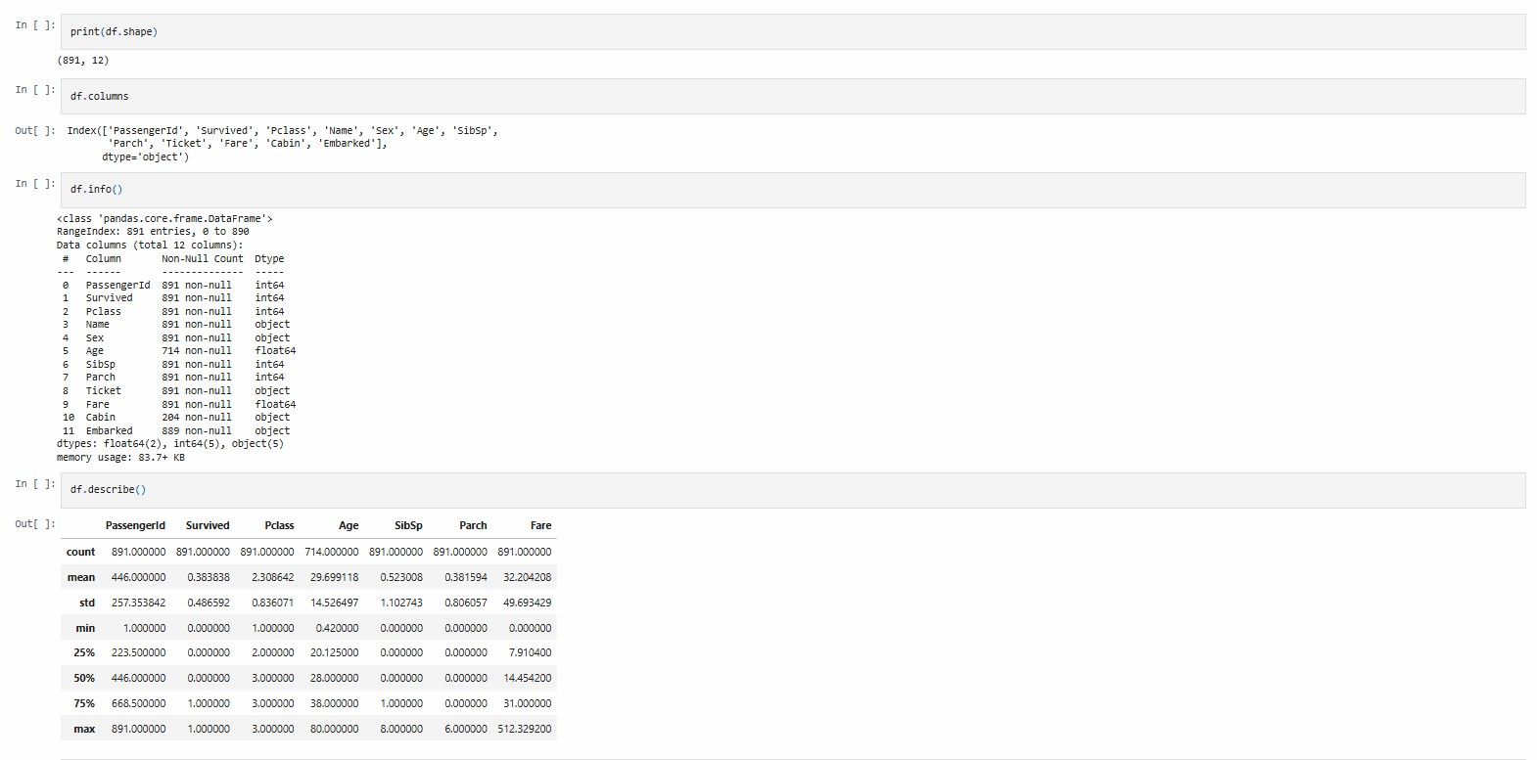
Output Description:
The dataset is successfully loaded into a Pandas DataFrame and its initial structure is examined. The Titanic dataset contains 891 rows and 12 columns. The output displays the first and last records, column names, data types, and statistical information such as mean, minimum, maximum, and standard deviation. This step helps in understanding the dataset before applying preprocessing techniques.

Check and Handle Missing Values
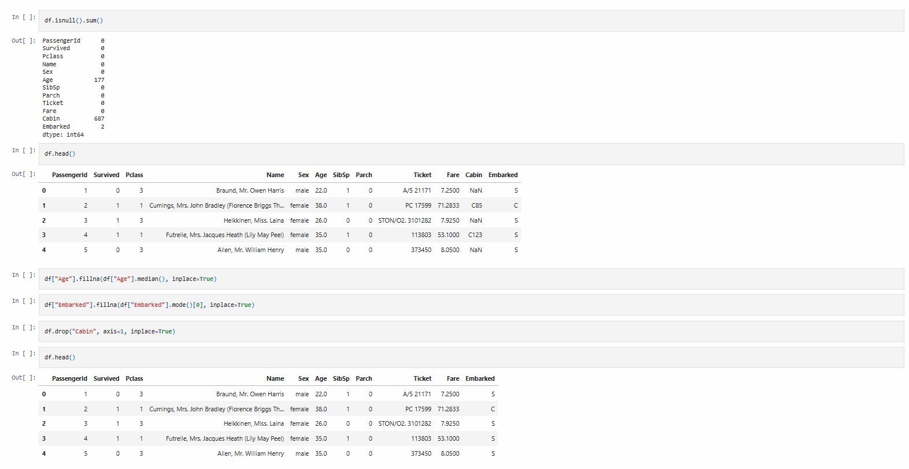
Output Description:
The missing-value analysis identifies missing values in the Age, Cabin, and Embarked columns. Missing Age values are replaced using the median, while missing Embarked values are filled using the mode. The Cabin column is removed because it contains a large number of missing values. The duplicate check shows 0 duplicate records, confirming that no duplicate rows are present in the cleaned dataset.

Check Duplicates and Outliers
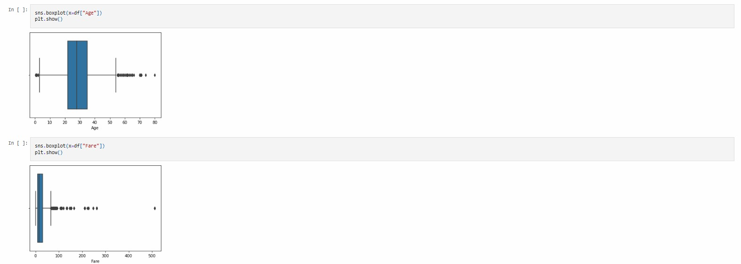
Output Description:
Boxplots are used to identify possible outliers in the Age and Fare columns. The Interquartile Range (IQR) method is then applied to calculate the lower and upper limits. Records falling outside these limits are removed from the dataset. The final boxplots show the distribution after outlier removal, resulting in cleaner numerical data for further processing. Remove Age and Fare Outliers
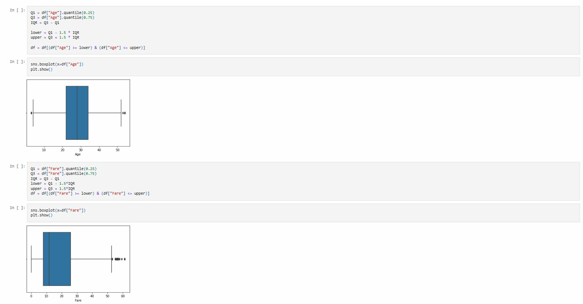
Output Description:
Categorical values are converted into numerical values so that they can be processed by machine learning algorithms. The Sex column is encoded as male = 0 and female = 1. Similarly, the Embarked column is encoded as S = 0, C = 1, and Q = 2. The displayed DataFrame confirms that the categorical values have been successfully converted into numerical form.

Encode Sex and Embarked
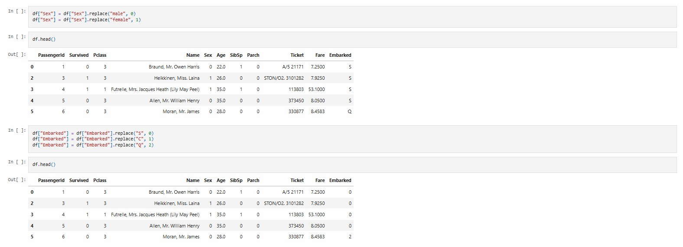
Output Description:
Different visualization techniques are used to understand important patterns in the Titanic dataset. Histograms show the distributions of Age and Fare, while count plots compare passenger gender and survival status. The Pclass versus Survived plot helps observe survival across passenger classes. The scatter plot shows the relationship between passenger Age and Fare.

Age and Fare Distribution
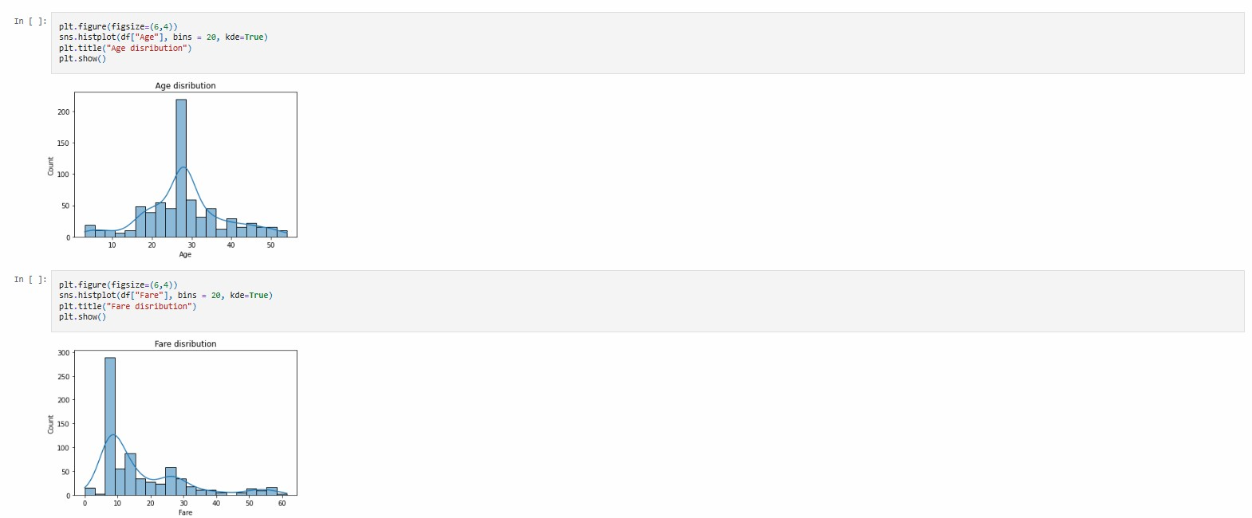
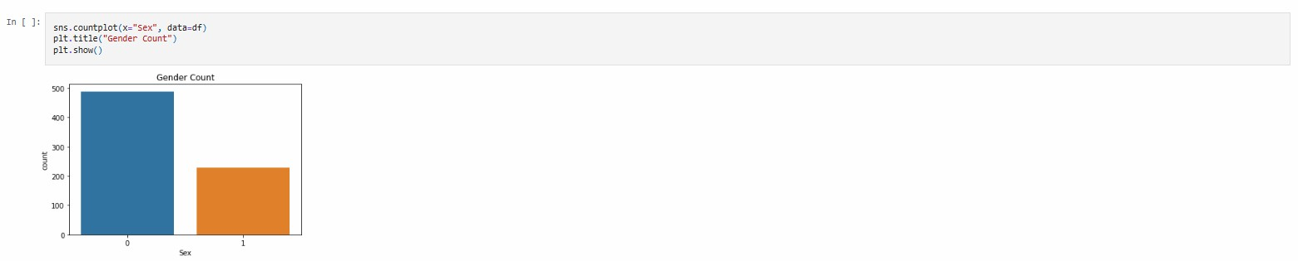

Output Description:
The output shows the distribution of Age and Fare values using histograms. The Age distribution represents how passengers are distributed across different age groups, while the Fare distribution shows the range of ticket fares. A Gender Count plot is also generated to display the number of male and female passengers. These visualizations help in understanding the basic distribution of important features in the Titanic dataset.

Relationship Visualization
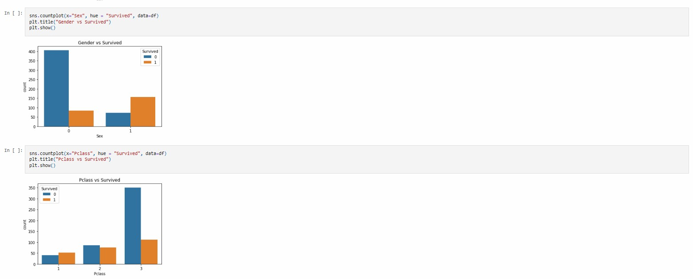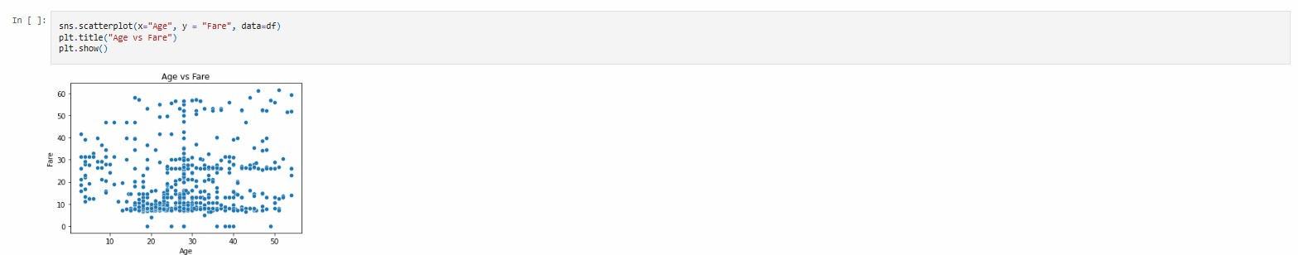
Output Description:
The output presents different relationships among the Titanic dataset features. The Gender vs Survived count plot compares the survival status of male and female passengers. The Pclass vs Survived plot shows the relationship between passenger class and survival. The Age vs Fare scatter plot represents the relationship between passengers' ages and their ticket fares. These plots help in identifying patterns and relationships between the selected variables.

Final Preprocessing
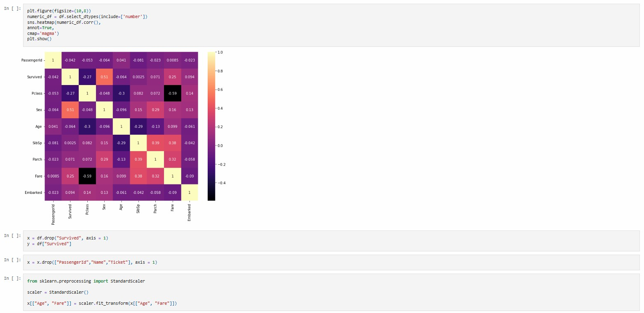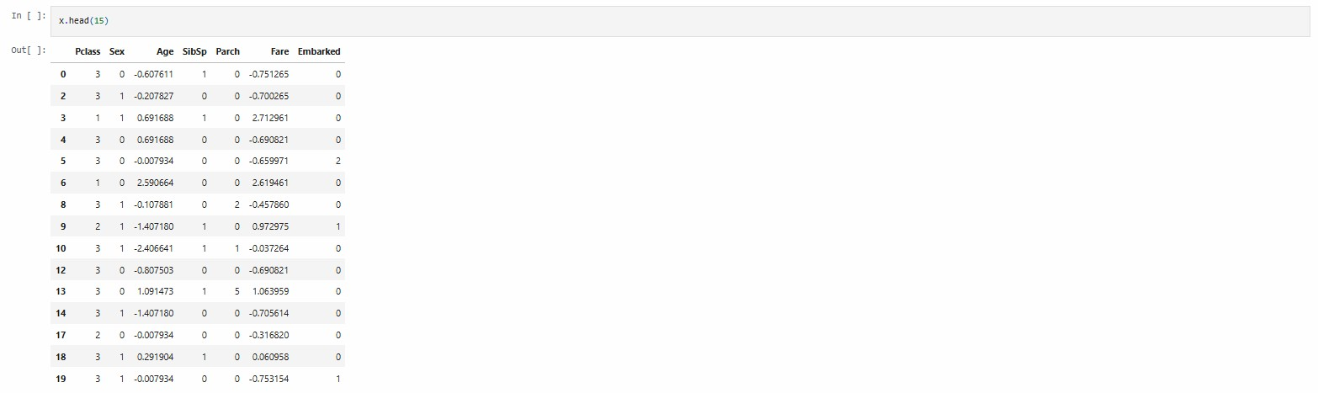
Output Description:
The output first displays a correlation heatmap for the numerical features of the dataset. The target variable, Survived, is separated from the input features, while unnecessary columns such as PassengerId, Name and Ticket are removed.
StandardScaler is then applied to the Age and Fare columns to standardize their values. The final output displays the processed feature data with standardized Age and Fare values, making the dataset suitable for further machine learning processing.

Splitting the Dataset into Training and Testing Sets
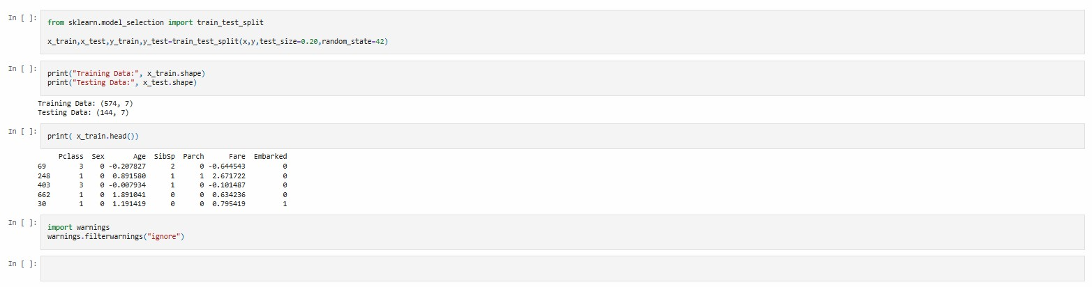
Output Description:
The dataset is divided into training and testing sets using the train_test_split() function. A test size of 20% is used with random_state=42 to obtain consistent results. The output shows 574 samples with 7 features for training and 144 samples with 7 features for testing. The first few rows of the training dataset are also displayed, confirming that the data has been successfully divided and is ready for machine learning model training.

Result –
The Titanic dataset was successfully preprocessed using Python and Pandas. The dataset was inspected to understand its structure, missing values, duplicate records, and statistical information. Missing values in the Age and Embarked columns were handled, while the Cabin column was removed due to excessive missing data. Outliers in the Age and Fare columns were detected and removed using the IQR method. Finally, categorical features such as Sex and Embarked were converted into numerical values, making the dataset suitable for further machine learning analysis.

VIVA QUESTIONS AND ANSWERS
Q1. What is Data Preprocessing?
Answer:
Data preprocessing is the process of cleaning and transforming raw data into a suitable format for machine learning. It includes handling missing values, removing unnecessary data, detecting outliers, encoding categorical values, visualization, and feature scaling.
Q2. Why is the Titanic dataset preprocessed before applying machine learning?
Answer:
The Titanic dataset contains missing values, categorical data, unnecessary columns, and outliers. Preprocessing removes or transforms these problems and makes the dataset suitable for training a machine learning model.
Q3. How were missing values handled in the Titanic dataset?
Answer:
Missing values in the Age column were replaced with the median value. Missing values in the Embarked column were replaced with its mode. The Cabin column was removed because it contained a large number of missing values.
Q4. What is the IQR method?
Answer:
IQR stands for Interquartile Range. It is used to detect and remove outliers. It is calculated as:
IQR = Q3 − Q1
The lower and upper limits are calculated as:
Lower Limit = Q1 − 1.5 × IQR
Upper Limit = Q3 + 1.5 × IQR
In this lab, the IQR method was applied to the Age and Fare columns.
Q5. Why is categorical encoding required?
Answer:
Machine learning algorithms generally require numerical input. Therefore, categorical values such as male, female, S, C, and Q are converted into numerical values. In this lab, Sex was converted to male = 0, female = 1, and Embarked was converted to S = 0, C = 1, Q = 2.
Conclusion:
The Titanic dataset was successfully prepared for machine learning by applying various data preprocessing techniques. Missing values were handled using median and mode, while the Cabin column was removed due to excessive missing data. Duplicate records and outliers were checked, and the IQR method was used to remove outliers from Age and Fare. Categorical features were converted into numerical values, and different visualizations were used to understand the dataset. Finally, unnecessary features were removed, Age and Fare were standardized using StandardScaler, and the dataset was divided into training and testing sets. Thus, the Titanic dataset was successfully cleaned and transformed into a suitable format for further machine learning model development.

